**Node classification example using a Graph Convolutional Network**

Our dataset is the paper citation network known as [Cora](https://relational.fit.cvut.cz/dataset/CORA) where graph nodes represent research papers and edges represent citation relationships between the papers. If a paper cites another paper then there is an edge between the two papers. Even though citations are directed, for the purpose of this tutorial we are going to consider the corresponding edges as undirected.

Each paper has an associated feature vector that encodes information about the vocabulary used in the paper. The feature vector for each paper has 1433 binary elements encoding presence (encoded as 1) or absence (encoded as 0) of 1433 key words extracted from the entire corpus of the papers’ texts.

Figure 5 demonstrates the [Bag-of-Words (BoW)](https://en.wikipedia.org/wiki/Bag-of-words_model) model for two papers in Cora. Each paper also has an attribute representing the *subject* of the paper. Each paper has one of seven subjects, such as Neural Networks, Probabilistic, Theory, etc. The dataset has 2708 papers (nodes) and 5429 citations (edges).

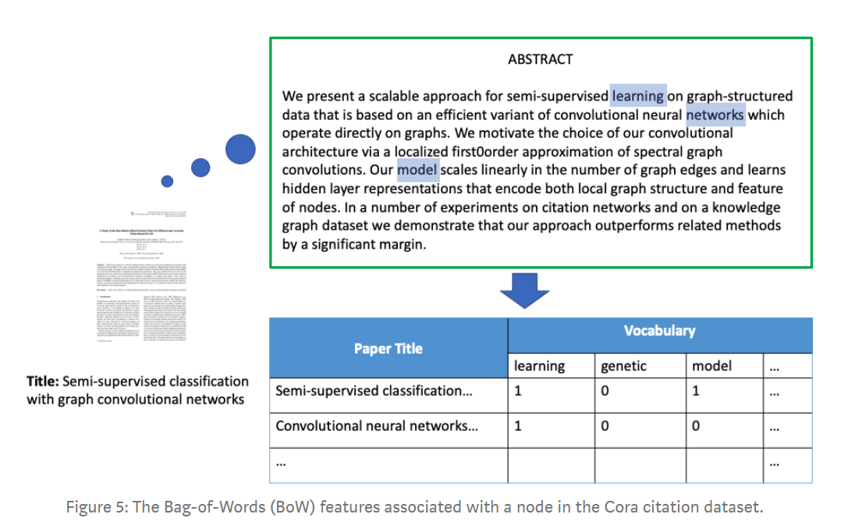

Our goal is to train a predictive model to infer the subject of a paper that was hidden from the machine learning algorithm during training. Since subject is categorical with 7 categories, this is a multi-class node classification problem.

As a baseline approach, we can use traditional machine learning methods to solve this problem ignoring the relationships between papers. We can stack the nodes’ feature vectors into a 2D array **F**, known as the design matrix, of dimensionality 2708x1433, and then train a classifier such as Logistic Regression, Neural Network, or Random Forest on a subset of the data. We can use the remaining data for evaluation of the classifier as validation and test sets.

This approach, which captures relationships between the vocabulary used in the papers and their subject, works fairly well. A 2-layer [Multi-Layer Perceptron](https://en.wikipedia.org/wiki/Multilayer_perceptron) (MLP) trained on only 140 samples (20 training samples per class) has been reported to achieve a test accuracy of approximately 55%, [3].

<https://medium.com/stellargraph/knowing-your-neighbours-machine-learning-on-graphs-9b7c3d0d5896>

### **Relational Machine Learning for Knowledge Graphs**

[Ivana Balazevic](http://www.inf.ed.ac.uk/people/students/Ivana_Balazevic.html)

Knowledge bases (KBs), such as Google Knowledge Graph, Wordnet [1], and Freebase [2] are important information resources, containing facts about the real world in the formof a large knowledge graph.  Each fact in the knowledge base is represented as a resource description framework (RDF) triplet: (subject, predicate, object), where subject and object are considered entities represented as nodes in the graph, and predicate is considered as a relation between those entities represented as a directed edge between the nodes.

Knowledge graphs are used for a wide variety of natural language processing tasks, e.g. question answering, information retrieval, co-reference resolution, etc.  However, the problem with such resources is that they are incomplete and lack reasoning capability, which inspired our work in this area.

Entity resolution with KG

**HR Recommender**

The **HR Recommender** is a semantic matchmaking tool based on a [**knowledge graph**](https://www.poolparty.biz/what-is-a-knowledge-graph). It is designed to connect employees with their coworkers, show them relevant projects, and let them know about interesting career opportunities within their organization.  
By selecting a demo user you assume their role and can see their matches. You can browse the visualization of the closest matches as well as look through sorted tables of matched coworkers, projects and open positions. The latter can be modified by adjusting the weight of different keywords from your user's profile. You can also simulate how to improve your user's profile and extracted tags.  After logging out you are able to select a different demo user.  
[See how it works](https://hr-recommender.poolparty.biz/hr-recommender/about).